**Program 4 (a)**

#include<iostream>

#include<math.h>

using namespace std;

int main()

{

double n,i,result;

n=2;

i=0;

while (i<=20)

{

result=pow(n,i);

cout<<result<<endl;

i++;

}

}

**Output**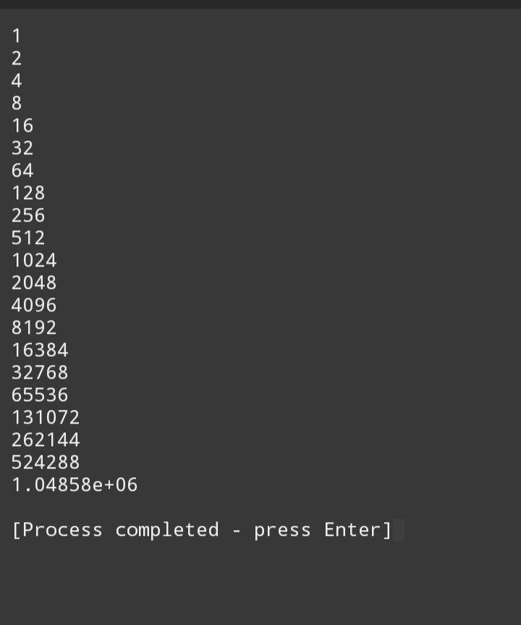

**Program 4 (b)**

#include<iostream>

#include<math.h>

using namespace std;

int main()

{

int a,b,sum;

sum=0;

cout<<"Enter a number"<<endl;

cin>>a;

int n=a;

cout<<"Enter another number"<<endl;

cin>>b;

while (n<=b)

{

if (n%2!=0)

{

sum+=n ;

n++;

}

n++;

}

cout<<sum<<endl;

}

**Output**

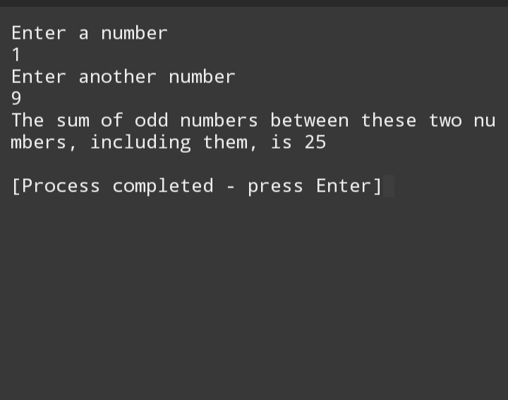

**Program 3 (a)**

#include<iostream>

#include<math.h>

using namespace std;

int main()

{

int n,sum;

n=2;

sum=0;

while (n<=100)

{

sum+=n;

n+=2;

}

cout<<"The sum of even numbers from 2 to 100 is. "<<sum<<endl;

}

**Output**

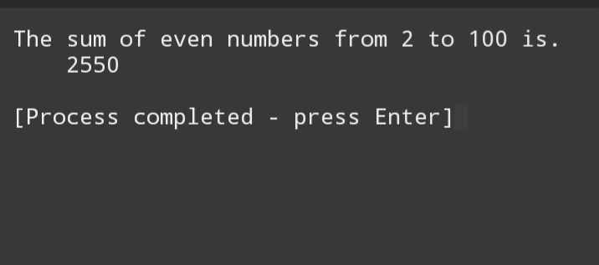

**Program 3 (b)**

#include<iostream>

#include<math.h>

using namespace std;

int main()

{

int n,sum,square;

n=1;

sum=0;

while (n<=10)

{

square=n*n;

sum+=square;

n++;

}

cout<<"The sum of squares from 1 to 100 is "<<sum<<endl;

}

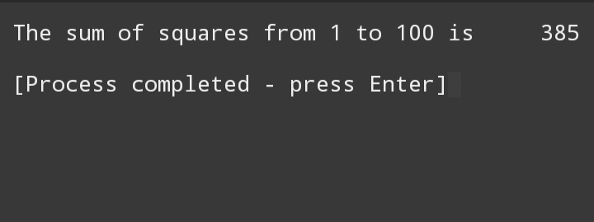

**Program 2**

#include <iostream>

#include<math.h>

Using namespace std;

Int main() {

Int a,b,result=0,T;

// a and B are input numbers

// T will be used to decide whether to terminate or not

Char operation;

Do {

Cout<<”Enter first number”<<endl;

Cin>>a;

Cout<<”Enter second number”<<endl;

Cin>>b;

Cout<<”Enter operation(+for addition,- for subtaction, * for multiplication, / for division , % for modulus , ^ for power”<<endl;

Cin>>operation;

Switch (operation) {

Case ‘+’:

Result=a+b;

Break;

Case ‘-‘:

Result=a-b;

Break;

Case ‘*’:

Result=a*b;

Break;

Case ‘/’:

If (b==0) {

Cout<<”invalid denominator”<<endl;

}

Result=a/b;

Break;

Case ‘%’:

If (b==0) {

Cout<<”invalid second number”<<endl;

}

Result=a%b;

Break;

Case ‘^’:

Result=pow(a,b);

Default:

Cout<<”invalid operation try again”<<endl;

}

Cout<<result<<endl;

Cout<<”If you want to continue,press Y, else press N”<<endl;

Cin>>T;

}

While (T==1);

}

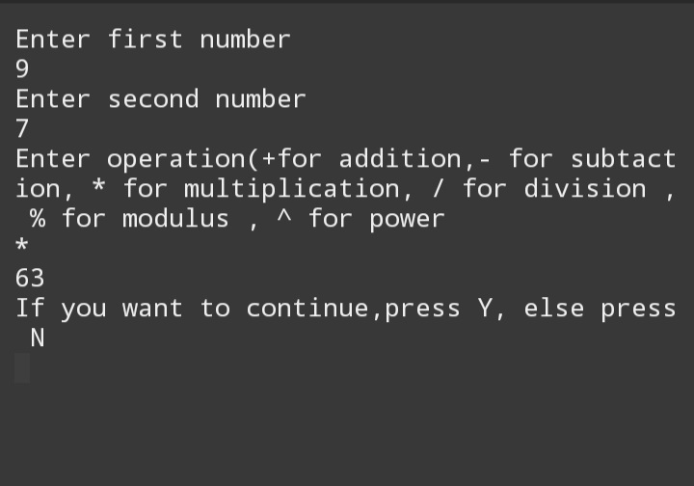

**Program 1**

#include <iostream>

using namespace std;

int main()

{

int x=1;

do

{

cout<<"enter a number: ";

cin >>x;

}

while (x>0);

}